**ABSTRACT**

**TERRA PROTECT**

. The system is built using the Wio Terminal, Seeed SenseCAP Kit, a solar panel, a lithium-ion battery, and a battery charger. The Wio Terminal acts as the main processing unit for the system and runs a computer vision algorithm that processes the data captured by a camera mounted on the device. The Seeed SenseCAP Kit provides a low-power, long-range communication solution that allows the device to send data to a remote server for analysis and prediction. The solar panel and lithium-ion battery provide a sustainable power solution for the device, making it suitable for deployment in remote coastal regions where power infrastructure may be limited. The battery charger ensures that the system remains operational by keeping the battery charged.

The system uses computer vision and machine learning algorithms to analyse satellite images and predict the risk of sand depletion and flooding in coastal regions. The device captures images of the coastline and extracts relevant features such as sand distribution, water levels, and weather patterns. The extracted features are then used to train machine learning models that predict future sand depletion and flooding events.

Terra Protect provides early warnings and alerts to coastal communities, allowing them to take proactive measures to protect their communities and ecosystems. The system promotes sustainable development practices and aims to minimize the negative impacts of sand depletion and flooding on coastal regions.

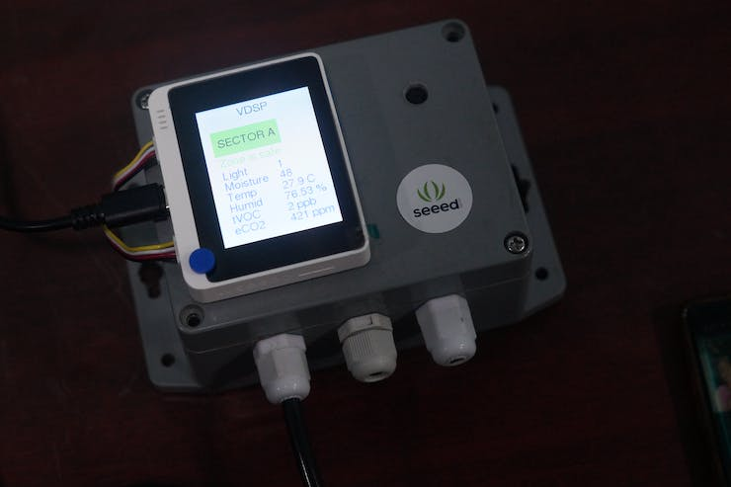

Final Product